TSA Cyber Directives Compliance for Log360
Strengthen cybersecurity and meet TSA Cyber Directives compliance with Log360.
Region: USA | Type: Cybersecurity Framework, Incident Management | Category: Compliance | Pricing: Free

Overview
The TSA Cyber Directives compliance extension in Log360 helps organizations meet the TSA Security Directives for Pipeline and Surface Transportation Cybersecurity, US directives requiring pipeline and rail operators to implement cyber risk management programs and report incidents within 24 hours by providing centralized log management, continuous threat monitoring, and incident detection capabilities. The platform supports TSA Cyber Directives requirements for governance, incident reporting, network segmentation, access control, vulnerability management, threat detection, incident response, and supply chain risk.
For Cybersecurity Program and Governance, Log360 tracks AD user auditing, GPO and policy changes, group management, and OU structure to evidence governance. To address Incident Reporting and CISA Coordination, the platform provides threat detection from FireEye, Trend Micro, McAfee, Windows threat reports, and network attack logs. The extension also supports Network Segmentation and IT/OT Isolation by providing capabilities that audits network device logon, account management, policy changes, attack reports, and firewall security configurations.

Key Features
- Access Control and Authentication: Log360 captures Windows and Unix logon/failed logon events and AD MFA logon compliance reports.
- Vulnerability and Patch Management: Log360 monitors Windows software updates, program inventory, firewall auditing, registry changes, and threat detection for vulnerability coverage.
- Continuous Monitoring and Threat Detection: Log360 delivers threat detection via FireEye, Trend Micro, Windows threat reports, network security monitoring, and detailed system event logging.
- Incident Response Planning and Testing: Log360 monitors Backup and Disaster Recovery infrastructure, policies, job statuses, and Windows Backup and Restore events.
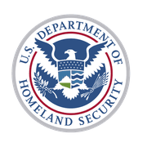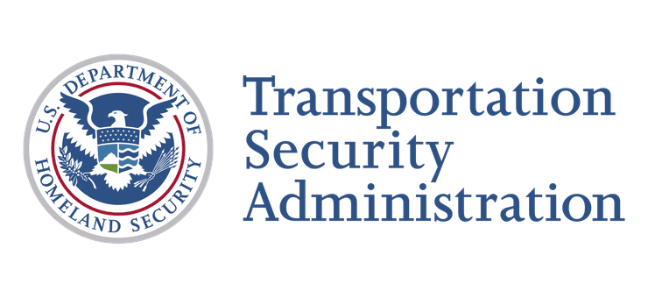

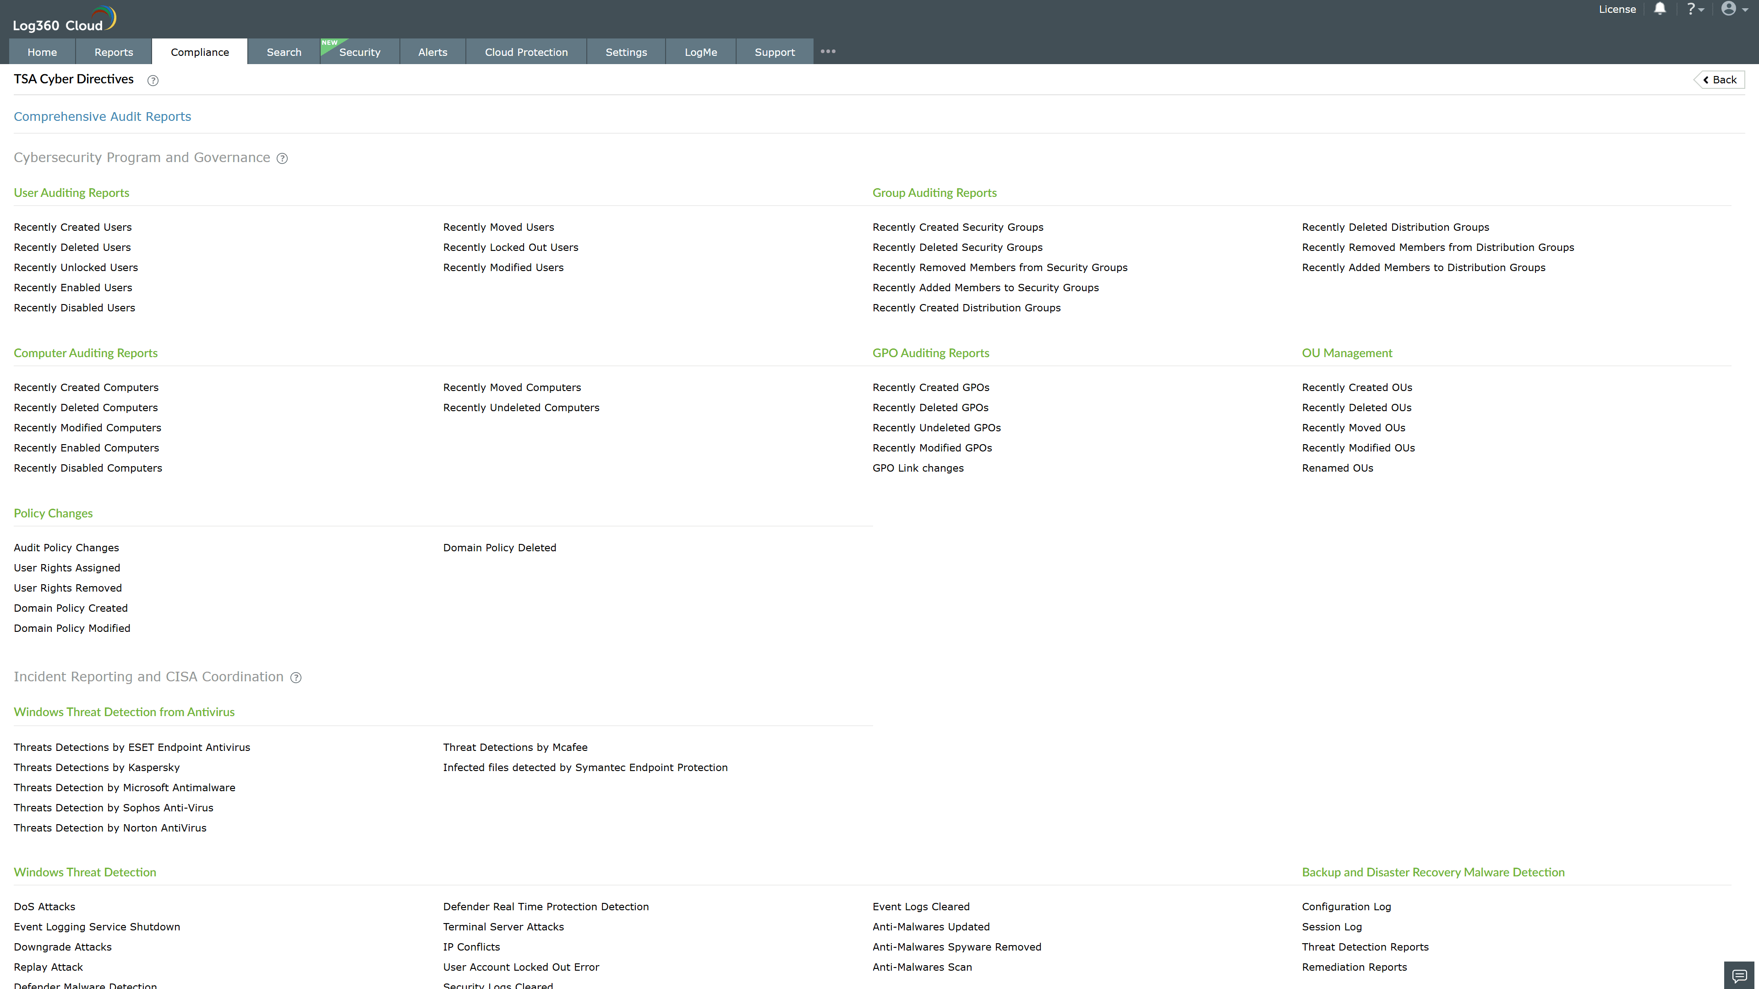
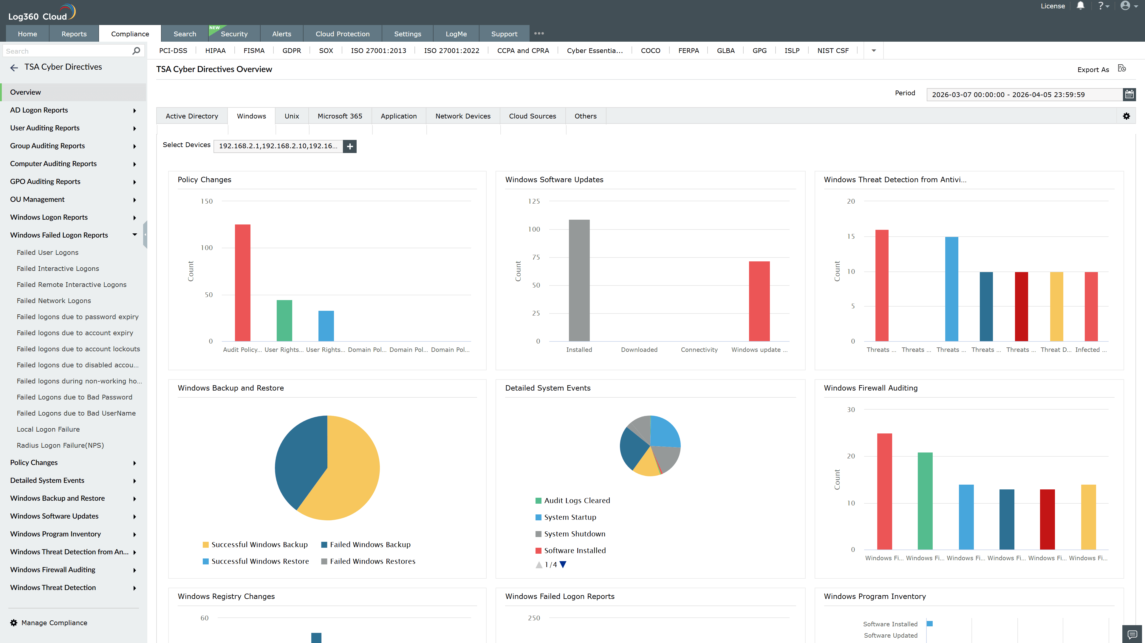
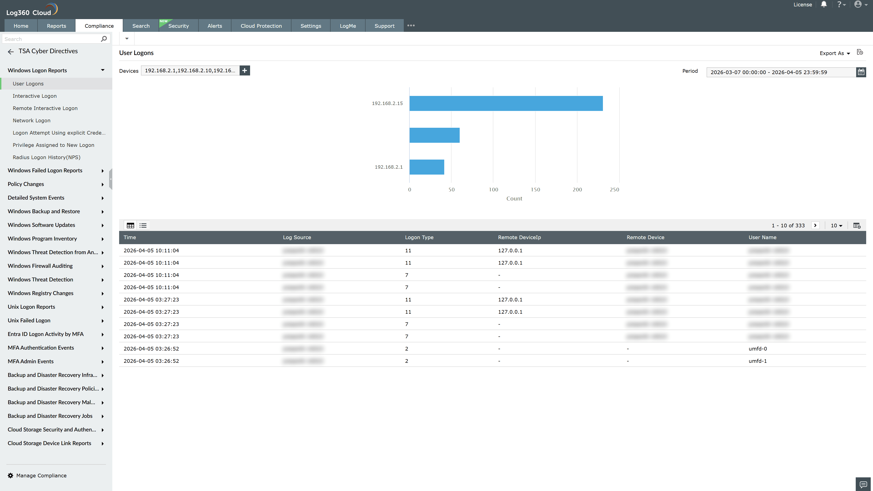
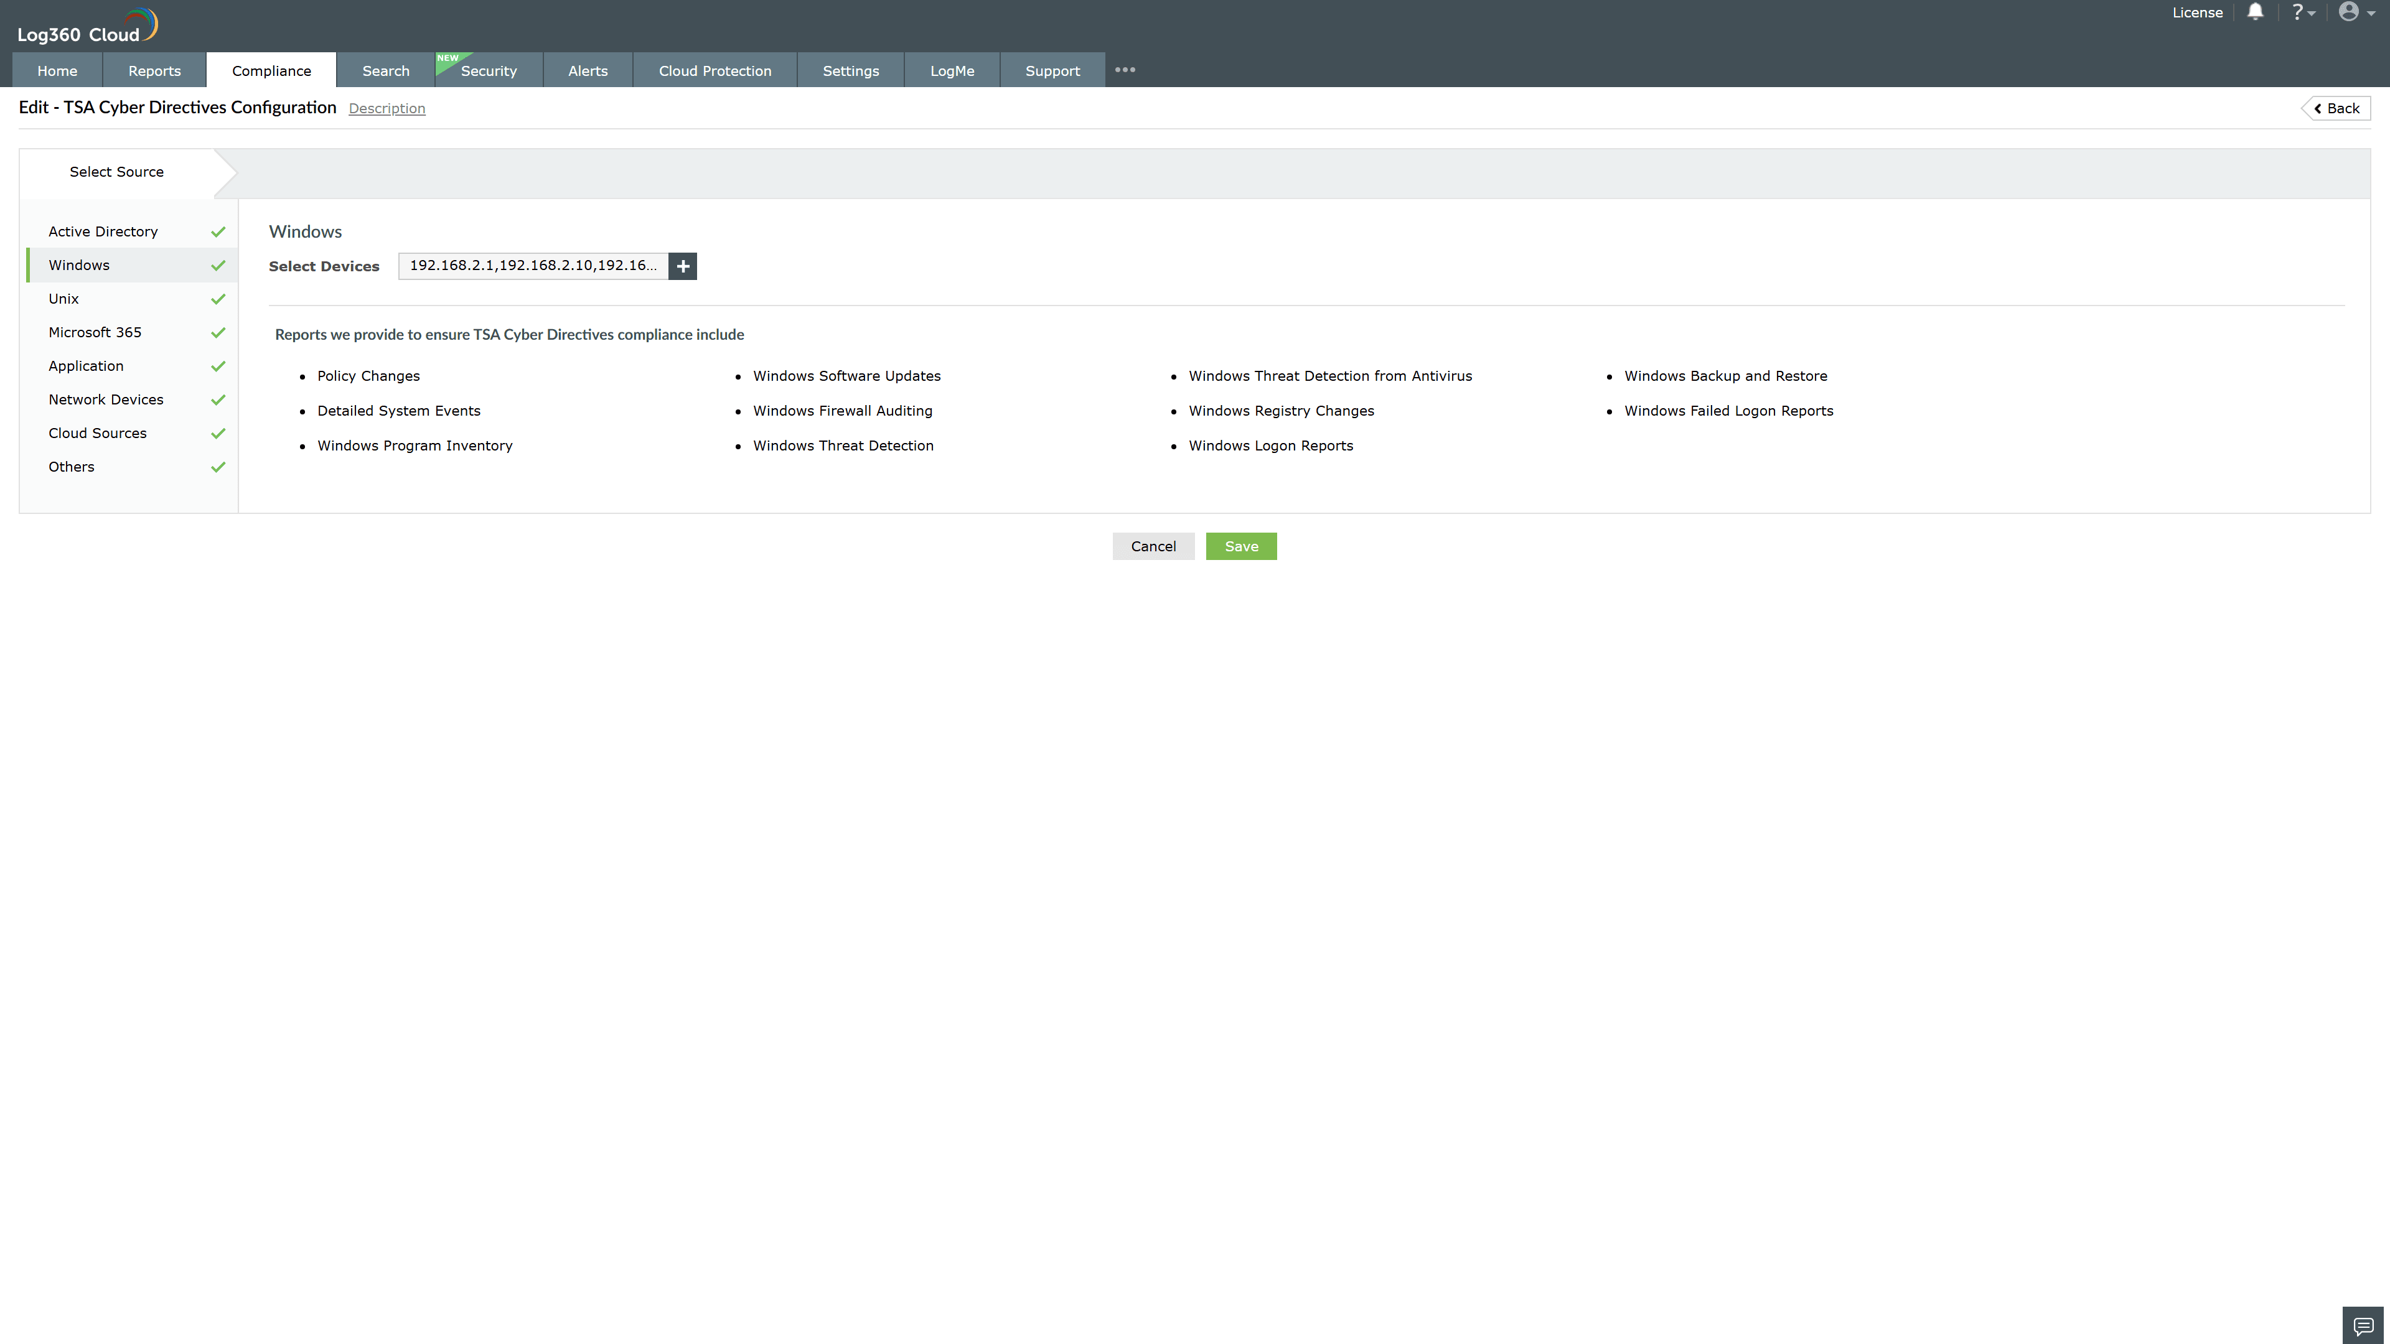
Valid Submission : Yes
Supported Editions : Free, Basic, Standard, Professional, MSSP
Help Document : https://www.manageengine.com/log-management/help/integrations/compliance-extensions.html
Help Video : Not provided
Tags : Log360, Compliance, Privacy monitoring, Data privacy, Regulatory compliance
Supported DCs : US, IN, JP, CA, AU, UK and EU
Privacy Policy:
Terms of Service:
Release Notes:
Predefined reports for the TSA Cyber Directives.

